Trend- and Reference-Guided Hybrid Modeling of Temperature-Dependent Thermophysical Properties
Shuai Zhang ª, Abdulelah S. Alshehri ^{b}, Mansour S. Alhoshan ^{b}, Anjan Tula ^{a,}∗
ª State Key Laboratory of Industrial Control Technology, College of Control Science and Engineering, Zhejiang University, Hangzhou 310027, China
^{b} Chemical Engineering Department, College of Engineering, King Saud University, Riyadh 11421, KSA
ABSTRACT
Temperature-dependent physicochemical property data are fundamental for process simulation, optimization, and sustainable molecular and product design. However, a critical data gap exists, with experimentally measured properties available for only a minuscule fraction of known chemicals, making their experimental determination resource-intensive and necessitating reliance on empirical methods. Furthermore, while numerous models predict single-point properties at fixed temperatures, accurately capturing continuous temperature-dependent behavior remains a significant challenge, as conventional approaches often neglect intermediate variations, leading to poor extrapolation. To address these limitations, we propose a mechanism-guided hybrid modeling framework that embeds physical knowledge into data-driven models. This framework integrates two complementary strategies: Strategy I corrects trend inconsistencies by constructing a temperature-dependent representation from multiple single-point predictors, incorporating both molecular descriptors and slope information, while Strategy II eliminates systematic bias by establishing a baseline function anchored by a high-accuracy single-point prediction and subsequently learning the residual deviations. Evaluation across ten thermophysical properties demonstrates the framework's effectiveness, with Strategy I reducing the mean squared error (MSE)MSE by 19% for traditional QSPR models, approximately 20% for explicit regression models, and 36% for black-box machine learning implicit models. Strategy II alone achieved a 47% MSE reduction for implicit models. This study confirms that embedding trend and slope-based mechanistic constraints enables physically consistent, bias-corrected, and accurate prediction of temperature-dependent properties, providing a scalable path to bridge the experimental data gap and accelerate computer-aided process engineering and molecular design.
Keywords: Temperature-dependent property prediction; Hybrid modeling; Mechanistic constraints; Machine learning; Slope-based correction; Bias correction

Nomenclature
$MSE$ Mean squared error
$R^{2}$ Coefficient of determination
$GC$ Group contribution method
$QSPR$ Quantitative structure-property relationship
$ML$ Machine learning
GBRT Gradient boosted regression trees
DNNs Deep neural networks
GNNs Graph neural networks
TGML Theory-guided machine learning
$C_{p}$ Heat capacity
$ΔHvap$ Enthalpy of vaporization
$U$ Internal energy
$ρ_{L}$ Liquid density
$H$ Pure component enthalpy
$Ex$ Pure component exergy
$G$ Gibbs free energy
$γ$ Isentropic exponent
$P_{vap}$ Vapor pressure
$V$ Volume
$mw$ Molecular weight
$η_{L}$ liquid viscosity

Introduction
Organic compounds are defined by their measurable properties, such as boiling point, solubility, and density.（shriner 2003）
Shriner, R. L.; Hermann, C. K. F.; Morrill, T. C.; Curtin, D. Y. The Systematic Identification of Organic Compounds; John Wiley & Sons: New York, 2003.
We can categorize these properties These properties can be categorized into two main classes: physical properties and chemical properties. Physical properties are attributes that can be determined without altering the chemical composition of the substance, such as melting point, boiling point, solubility, density, and refractive index. These parameters are fundamental for identifying purity and designing separation processes, with standard data often compiled in authoritative references like the CRC Handbook of Chemistry and Physics [1]. Conversely, chemical properties describe the behavior of a substance during chemical transformations, encompassing acidity/basicity, reactivity, redox stability, and the characteristic transformations of functional groups, with their underlying principles and mechanisms deeply elaborated in seminal texts such as March's Advanced Organic Chemistry [2]. These two classes of properties collectively form the cornerstone of functional applications for organic compounds. For example, the volatility and chemical inertness of a solvent make it an ideal reaction medium, while its purification relies on a profound understanding of its physical characteristics [3]. In pharmaceuticals, a drug's aqueous solubility and its metabolic reactivity within the body jointly determine its efficacy and safety, a core principle in rational drug design [4]. The mechanical strength of a polymeric material directly originates from the polymerization capability of its monomers [5]. Similarly, the optoelectronic function of conjugated organic molecules is dictated by their specific electronic structures [6]. Therefore, the physical and chemical properties of organic compounds act as the critical bridge between molecular structure and macroscopic function.

$MSE$
$R^{2}$
$GC$
$QSPR$
$ML$
$C_{p}$
$ΔHvap$
$U$
$ρ_{L}$
$H$
$Ex$
$G$
$γ$
$P_{vap}$
$V$
$mw$
$η_{L}$
Among these, the physical properties—particularly those relevant to energy and phase behavior—are paramount for process design and optimization. From a thermodynamic standpoint, the physical properties of organic compounds can be fundamentally classified into two distinct categories based on their relationship with temperature: single-point properties and temperature-dependent properties. Single-point properties are a class of characteristic constants for a substance. Common examples are the critical pressure, standard enthalpy of formation, and normal boiling point. These properties provide a definitive fingerprint that is fundamental to a material's identity. In contrast, Temperature-dependent properties are those whose values intrinsically vary with thermal conditions. Their values are meaningful only when associated with a specific temperature. Primary examples are heat capacity, which quantifies a substance's energy storage ability, and vapor pressure, which defines its phase equilibrium behavior. These properties are inherently dynamic and must be considered across a temperature range to fully characterize a substance's behavior. This fundamental distinction is critical for the accurate application of physical properties in both analysis and design.
Among these, the physical properties—particularly those relevant to energy and phase behavior—are paramount for process design and optimization. From a thermodynamic standpoint, the physical properties of organic compounds can be fundamentally classified into two distinct categories based on their relationship with temperature: single-point properties and temperature-dependent properties. (Reid et al., 2001) Single-point properties are a class of characteristic constants for a substance. Common examples are the critical pressure, standard enthalpy of formation, and normal boiling point. These properties provide a definitive fingerprint that is fundamental to a material's identity. (Chao et al., 1998) In contrast, Temperature-dependent properties are those whose values intrinsically vary with thermal conditions. Their values are meaningful only when associated with a specific temperature. Primary examples are heat capacity, which quantifies a substance's energy storage ability, and vapor pressure, which defines its phase equilibrium behavior. (Mondal et al., 2023) These properties are inherently dynamic and must be considered across a temperature range to fully characterize a substance's behavior. This fundamental distinction is critical for the accurate application of physical properties in both analysis and design. (Reid et al., 2001)
Reid, R. C., Prausnitz, J. M., & Poling, B. E. (2001). The Properties of Gases and Liquids (5th ed.). McGraw-Hill.
Chao, J., Gadalla, N. A. M., Gammon, B. E., Marsh, K. N., Rodgers, A. S., & Somayajulu, G. R. (1998). Thermodynamic and Thermophysical Properties of Organic Nitrogen Compounds. Journal of Physical and Chemical Reference Data, 27, 115-148.
Mondal, B., Mukherjee, T., Finch, N. W., Saha, A., Gao, M. Z., Palmer, T. A., & DebRoy, T. (2023). Vapor Pressure versus Temperature Relations of Common Elements. Materials, 16(1), 50.

The obtaining of these properties, however, presents a formidable challenge. Practitioners generally rely on three approaches: (i) retrieving data from established databases; (ii) performing new laboratory measurements; and (iii) employing property prediction models. Each of these methods faces significant limitations. The primary constraint of database retrieval is the severe scarcity of available data. This is clearly illustrated by the disparity between large molecular registries and curated handbooks: while PubChem lists over 100 million compounds(Kim et al., 2016), the authoritative CRC Handbook of Chemistry and Physics contains single-point properties for only approximately 10,900 substances, and this number plummets to a mere hundreds for compounds with fully parameterized temperature-dependent properties. Meanwhile, laboratory measurement, while considered the gold standard, is often time-consuming, expensive, and impractical for screening large numbers of compounds.( Hachmann et al., 2011) These inherent drawbacks make property prediction models the most viable and practical approach for obtaining necessary properties in the early stages of design.
Consequently, the field of property prediction has seen substantial research activity. However, this effort has been mainly concentrated on the development of models for single-point properties, benefiting from the relative abundance of standardized data points. In stark contrast, the development of models for temperature-dependent properties remains a notably under-explored area.( Butler et al., 2018) This research gap is not only due to the scarcity of comprehensive experimental data but, more fundamentally, to the significant increase in modeling complexity. Predicting a single value is a fundamentally different and simpler task than learning a continuous function of temperature. Such models must simultaneously capture the influence of molecular structure and thermal behavior, often requiring them to adhere to underlying physical laws and generalize across both chemical space and a continuous temperature domain. This stark data gap motivates the need for accurate and efficient predictive models that can estimate temperature-dependent thermophysical properties for compounds lacking experimental data.
This pronounced disparity in research focus is quantitatively illustrated in Fig.1, which presents a survey of predictive modeling publications from the past five years. The data clearly show that while single-point property prediction dominates the literature, the development of predictive models for temperature-dependent properties remains critically underdeveloped. This contrast underscores the pressing need for accurate and efficient approaches specifically aimed at estimating thermal behavior for the vast number of compounds lacking experimental data.
Kim, S., Thiessen, P. A., Bolton, E. E., Chen, J., Fu, G., Gindulyte, A., … & Bryant, S. H. (2016). PubChem substance and compound databases. Nucleic Acids Research, 44(D1), D1202-D1213.
Hachmann, J., Olivares-Amaya, R., Atahan-Evrenk, S., Amador-Bedolla, C., Sánchez-Carrera, R. S., Gold-Parker, A., … & Aspuru-Guzik, A. (2011). The Harvard clean energy project: Large-scale computational screening and design of organic photovoltaics on the world community grid. The Journal of Physical Chemistry Letters, 2(17), 2241-2251.
Butler, K. T., Davies, D. W., Cartwright, H., Isayev, O., & Walsh, A. (2018). Machine learning for molecular and materials science. Nature, 559(7715), 547-555.

Fig.1 Number of Property Prediction Studies (2020-2024)
Fig.1 Number of research works related to temperature-dependent and single-point properties in organic compounds (2020-2024) .Data for this table was retrieved from Web of Science, using specific keywords related to temperature-dependent properties and single-point properties. For the full list of keywords used, please refer to the Appendix.
To address the challenge of predicting temperature-dependent properties, several modeling approaches have been developed. Among them, three categories form the cornerstone of current research: group contribution (GC)GC methods, quantitative structure–property relationship (QSPR) QSPR models, and machine learning (ML) ML approaches. Many of the aforementioned models are fundamentally based on molecular structure information. For predicting single-point properties at a fixed temperature, relying solely on structural descriptors has proven highly effective. However, a fundamental flaw emerges when extending this approach to model continuous temperature dependence. The prevailing approach treats data points at different temperatures for the same substance merely as an expansion of the dataset volume, where each (temperature, property) pair is processed as an independent sample. This treatment inherently disregards the intrinsic physical correlation between points on the same temperature-property curve. Consequently, conventional models that fit property values to discrete (temperature, structure) pairs fail to learn the continuous functional relationship, leading to predictions that lack physical consistency, manifesting as incorrect curvature and poor extrapolation beyond the training range.
The remainder of this paper is organized as follows: Section 2 reviews the group contribution (GC)GC principle and common data-driven models; Section 3 describes the two strategies; Section 4 presents comparative results against conventional models；Section 5 provides an outlook for future work.
To address the challenges associated with predicting temperature-dependent properties—where model accuracy often deteriorates due to complex thermal behaviors—we propose two generic enhancement strategies designed to improve the predictive performance of existing models. The first strategy, termed Trend-Guided Modeling, leverages single-point prediction models to infer the underlying temperature-dependent trends of target properties. The second strategy, referred to as Bias-Corrected Hybrid Modeling, uses single-point prediction models to directly regress a baseline model and correct systematic prediction bias.
The core contribution of this work lies in the development of a model-agnostic framework that can effectively enhance the performance of a wide range of existing property prediction models. In addition, this work advances the state of the art in the following aspects:
1. Performance: Evaluation across ten thermophysical properties demonstrates the effectiveness of the proposed framework. Strategy I reduces the mean squared error (MSE) by approximately 19% for traditional QSPR models, about 20% for explicit regression models, and 36% for implicit black-box machine learning models. Strategy II further improves implicit models, achieving an average MSE reduction of 47%.
2. Extensibility: Strategy I can be readily integrated into most existing modeling approaches with minimal modification, while Strategy II provides a general predictive paradigm for temperature-dependent properties that lack dedicated modeling formulations.
3. Open-source availability: All developed models, curated datasets, and experimental protocols are made publicly available to support reproducibility and facilitate future research.

2. The transition from single-point to temperature-dependent models
The prediction of properties for organic compounds is primarily built upon three computational approaches: group contribution (GC) GC methods, quantitative structure-property relationship (QSPR) QSPR modeling, and machine learning (ML) ML approaches. These methods provide the fundamental framework for estimating properties at fixed temperatures, while also forming the essential building blocks for constructing models that capture temperature-dependent behavior.

2.1 Group contribution methods

2.1.1 Fundamental GC Model
In the GC model, the target property is tied to molecular structure: a molecule is decomposed into functional groups, and group contributions are regressed from experimental data, and the prediction is obtained by summing these contributions. A common formulation is:
$$\begin{aligned}f\left(X\right)=\sum_{i=1}^{N}{C_{i}N_{i}}\#（1）\end{aligned}$$
In this notation, $X$ denotes a given molecule and $f\left(X\right)$ its target property. $N_{i}$ represents the number of i-th functional groups in $X$. $C_{i}$are the corresponding regression coefficients; and $N$ are the numbers of groups defined in the library. Based on this basic expression, prior studies have used GC models to predict pure-component properties and environmental properties [7,8,9].

2.1.2 Extending the GC frameworks: parameterizing physical equations
The GC method is extended by using it to predict the parameters of thermodynamically sensible temperature functions, rather than the property value directly. The values of these GC-derived parameters directly determine the slope, curvature, and vertical offset of the resulting property-temperature curve.
The coefficients in a predefined temperature function are obtained by summing group contributions. In engineering practice, this common approach chooses a thermodynamically sensible temperature function as the backbone and then uses the GC framework to model that function’s parameters, yielding the full property–temperature curve. This workflow and its essentials are well captured by early foundational work [10]. Early temperature-dependent predictive models include:
- Heat capacity polynomial
$$\begin{aligned}C_{p}=\left[∑\left(a\right)-37.93\right]+\left[∑\left(b\right)+0.210\right]T+\left[∑\left(c\right)-3.91×{10}^{-4}\right]T^{2} \\ +\left[∑\left(d\right)+2.06×{10}^{-7}\right]T^{3}\#（2）\end{aligned}$$
(2) Liquid-viscosity (Andrade-type) relation
$$\begin{aligned}η_{L}=mw×\exp\left\{\frac{∑\left(η_{a}\right)-597.82}{T}+∑\left(η_{b}\right)-11.202\right\}\#（3）\end{aligned}$$
Here, $C_{p}$ denotes the ideal-gas heat capacity. $∑\left(a\right)$ means the coefficient $a$ is obtained by group-contribution regression and then summed over the molecule’s structural groups; the coefficients $b$, $c$, and $d$ are defined in the same way. the GC model serves to regress the temperature-dependent coefficients up to third order (a, b, c, d), acting essentially as a polynomial fitting function. The outcome of this regression directly fixes the values of these coefficients, thereby governing the predicted temperature dependence of the heat capacity.
For the viscosity model, $mw$ is the molecular weight, $η_{L}$ denotes the liquid viscosity, and $∑\left(η_{a}\right)$ indicates that the parameter $η_{a}$​ is obtained by group-contribution regression and summed over groups; $∑\left(η_{b}\right)$​ is defined analogously. The GC regression determines the group increments $η_{a}$ and $η_{b}$; these increments govern the magnitude and temperature sensitivity of the exponential term and thus directly dictate the predicted viscosity magnitude and its temperature trend.
Ceriani et al. [11] extend the same philosophy to two key temperature-dependent properties of organic liquids. For liquid heat capacity, they adopt a temperature-linear model whose intercept and slope are decomposed into group contributions:

$$\begin{aligned}C_{p}=\sum_{k}{N_{k}\left(A_{K}+B_{K}T\right)}\#（4）\end{aligned}$$
$N_{k} represent$ the number of each groups, $A_{K}$and $B_{K}$is the parameters needed to be tuned.
For the heat of vaporization they first fit a GC-parameterized vapor-pressure relation and then apply Clausius–Clapeyron to obtain an explicit temperature function.
$$\begin{aligned}H_{i}^{vp}=-R\left(\frac{1.5*B_{i}^{'}}{T^{0.5}}+{C }_{i}^{'}*T+D_{i}^{'}*T^{2}\right)\#（5）\end{aligned}$$
$$\begin{aligned}B_{i}^{'}=\sum_{k}{N_{K}*\left(B_{1K}+M_{i}B_{2K}\right)+β\left(f_{0}+N_{C }*f_{1}\right)}\#\left(6\right)\end{aligned}$$
$$\begin{aligned}C_{i}^{'}=\sum_{k}{N_{K}*\left(C_{1K}+M_{i}C_{2K}\right)+γ\left(f_{0}+N_{C }*f_{1}\right)}\#（7）\end{aligned}$$
$$\begin{aligned}D_{i}^{'}=\sum_{k}{N_{K}*\left(D_{1K}+M_{i}D_{2K}\right)+δ\left(f_{0}+N_{C }*f_{1}\right)}\#（8）\end{aligned}$$
R is the gas constant (8.3144 J/g mol K for $H_{i}^{vp}$ in J / gmol).Where $N_{k}$is the number of groups $k$in the molecule; $M_{i}$is the component molecular weight; $B_{1k},C_{1k},D_{1k},B_{2k},C_{2k},D_{2k}$are group-contribution coefficients; $f_{0}$and $f_{1}$, $β$,$γ\text{ and} δ$are parameters obtained by regression of experimental data; $k$denotes the groups of component $i$; $N_{c}$is the total number of carbon atoms in the molecule. This specific implementation enhances the parameter prediction by integrating not only the counts of molecular groups but also supplemental molecular characteristics such as the total carbon count and molecular weight. These additional descriptors are incorporated alongside group contributions within the regression framework, with each feature assigned its own independently fitted coefficient.
This evolution exemplifies the broader development of GC methods for temperature-dependent prediction. The foundational framework established by Joback and Reid [10] demonstrated the prediction of properties like ideal gas heat capacity. Subsequent refinements introduced optimized parameters [11], group-group interactions for improved accuracy [12], and specialized models for industrial systems such as fatty compound viscosity [13]. These advancements underscore the continued relevance of GC methods, balancing interpretability and simplicity with growing predictive capability for key thermophysical properties.

2.2 Quantitative structure–property relationship (QSPR) QSPRmodels

2.2.1 Fundamental QSPR Principles
QSPR assumes that systematic changes in molecular structure translate into changes in measurable macroscopic properties. In practice, it builds a supervised mapping from molecular descriptors or fingerprints to target properties across chemical space. Unlike physics-based simulation, QSPR depends strongly on a curated training set with well-defined structures and reliable measurements; data quality, consistent units and baselines, and laboratory-to-laboratory differences ultimately limit model reliability. Because experimental data are noisy and many property distributions are skewed, practitioners often apply distribution-stabilizing transforms such as logarithms or reciprocals, standardize features, and adopt clear outlier policies. Model inputs are as diverse as process variables (for uncertain structures), topology descriptors, and hybrid sources that capture history-dependence.
A typical QSPR workflow proceeds through descriptor generation, feature selection or regularization, model fitting, and external validation with an explicit applicability-domain assessment to prevent leakage and overfitting. Common, reliable baselines include support vector regression and other kernel methods for small to medium data sets; gradient-boosted trees such as LightGBM for tabular chemical features with useful feature-importance diagnostics; and Gaussian processes when calibrated uncertainty is required or when inputs mix qualitative and quantitative factors, including grouped categorical variables. For sound inference and decision support, Bayesian methods help with model comparison and calibration; when deep models are used, neural-network uncertainty quantification can be layered on to provide trustworthy confidence estimates.

2.2.2 Extending the QSPR approach: temperature as an input feature
In contrast to the equation-based approach of GC methods, the QSPR approach incorporates temperature dependence by integrating the temperature variable directly into the statistical or machine learning model. The implementation varies significantly in complexity and physical grounding, establishing mathematical correlations between a compound's molecular descriptors and its target properties through statistical learning.
The foundational work of Todeschini and Gramatica [14] systematically developed the WHIM descriptors that capture 3D structural information, forming the basis for many subsequent QSPR models of temperature-dependent properties. Building on such descriptor systems, two main strategies have emerged for handling temperature dependence.
A common and more physically informed strategy is to leverage established empirical relationships. For instance, the temperature dependence of properties like vapor pressure is often well-described by specific non-linear functions. In such cases, the QSPR model predicts the parameters of these established temperature-dependent equations using molecular descriptors. This hybrid approach combines the data-driven power of QSPR with foundational physical chemistry models, as demonstrated by Sosnowska et al. [15] who employed QSPR-predicted enthalpy of vaporization within the Clausius-Clapeyron equation to characterize temperature-dependent vapor pressure of persistent organic pollutants.
For a more flexible, purely data-driven approach, the strategy expands to directly incorporate temperature as a standard numerical input feature. The model thus learns a function: Property =F(Molecular Descriptors, T). This allows algorithms to discover temperature-property relationships directly from data, without being constrained by specific pre-defined equations. Notable applications include Huang et al. [16] developing a temperature-dependent QSPR model for vapor pressure of polycyclic aromatic hydrocarbons, Cheng et al. [17] integrating temperature with quantum chemical descriptors to predict ozonation reaction rate constants, and Yin et al. [18] explicitly incorporating temperature as an independent variable to predict gas heat capacity over an exceptionally wide temperature range (50-1500 K).
Regardless of the implementation, the core of the QSPR strategy is its reliance on data to reveal the nature of temperature dependence, whether by parameterizing semi-empirical forms or through completely learned relationships.

2.3 Machine learning models

2.3.1 Fundamental ML approaches
Machine learning provides a powerful, data-driven approach for property prediction, capable of learning complex, non-linear relationships directly from data. Unlike GC and QSPR which often rely on pre-defined features (functional groups or molecular descriptors), ML models can automatically learn relevant representations from raw or minimally processed inputs, such as molecular fingerprints, SMILES strings, or even molecular graphs. Common algorithms used in this domain range from interpretable models like gradient boosted regression trees (GBRT) GBRT to highly flexible deep neural networks (DNNs)DNNs. The core task remains establishing a mapping from a molecular representation to a target property, but ML excels at discovering intricate patterns that may be elusive to traditional methods.

2.3.2 Extending ML for temperature-dependent prediction
The extension of ML to temperature-dependent prediction is conceptually straightforward yet powerful: temperature is incorporated as an additional input variable. The model thus learns a function of the form Property = F(Molecular Descriptors , T). This allows the algorithm to discover the combined effect of structure and thermal energy on the property directly from the data.
This approach has been successfully applied to a wide range of properties. For instance, tree-based models like GBRT and LightGBM have been used to predict liquid heat capacity [19] and solubility [20] across temperatures. A significant advancement lies in the use of graph neural networks (GNNs)GNNs, which natively process molecular structures. As Rittig et al. demonstrated, GNNs can accurately predict properties like activity coefficients in ionic liquids across temperatures, generalizing even to unseen compounds [21].
The approach continues to evolve beyond purely data-driven models. Theory-guided machine learning (TGML) TGML represents a frontier, where physical knowledge or simulations are integrated into the learning process. As pioneered by Zobeiry et al. for composite materials, this hybrid approach can overcome data scarcity and enforce physical consistency, offering a promising path for complex systems [22]. This progression from standard models to physics-informed architectures underscores ML's adaptability in modeling continuous temperature-dependent behavior.

2.4 Limitations of traditional temperature-dependent models
The GC framework for temperature-dependent prediction faces a dual challenge. First, The physical equation it relies on is itself an approximation, introducing a systematic error by design. At the same time, the experimental data used for calibration contains random noise. Consequently, the model is tasked with an imperfect fit: it uses an approximate equation to describe noisy data. This fundamental mismatch prevents the model from achieving high precision, as it cannot resolve the inherent conflict between its simplified theoretical basis and the messy reality of experimental measurements.
A key limitation of complex QSPR/ML models lies in their opaque internal logic—the reasoning process behind their predictions cannot be easily traced or understood. This lack of transparency is compounded by the absence of embedded physical constraints, meaning predictions may diverge from thermodynamic principles without warning. While these models can capture intricate patterns, their inability to provide physical justification or guarantee thermodynamic consistency undermines their reliability in scientific and engineering applications where such understanding is crucial.
The theoretical limitations discussed above manifest clearly in practical predictions. The following figures provide a visual demonstration of these issues, contrasting model outputs with experimental data to reveal characteristic errors: the GC model's inherent difficulty in closely tracking the true variation trend, and QSPR/ML models producing sudden, unphysical jumps at certain points due to their lack of physical consistency.
The theoretical limitations discussed above become evident in practical predictions, as demonstrated by the following figures. These figures compare model outputs with experimental data to highlight the challenges faced by the models in accurately predicting temperature-dependent properties.
Figure 2: Prediction Performance of the GC Model for Features with Explicit Expression
For this analysis, only three features have explicit prediction models available. The figure shows the performance of the GC model in predicting features with explicit expression. The GC model struggles to closely follow the true variation trend of the experimental data, particularly in regions where the data exhibits rapid changes. This reflects the inherent difficulty of the GC model in capturing the temperature-dependent behavior of the features accurately.
Figure 3: QSPR Model Performance for Predicting Implicit Expression Feature Models
The prediction results shown in this figure are for substances across four of the ten evaluated features. This figure demonstrates the performance of the QSPR model in predicting implicit expression feature models. The QSPR model exhibits unphysical jumps at certain points, which result from the lack of physical consistency in the model. These sudden discontinuities cause the predictions to deviate sharply from the experimental data, highlighting the challenges associated with maintaining consistency when physical principles are not incorporated.

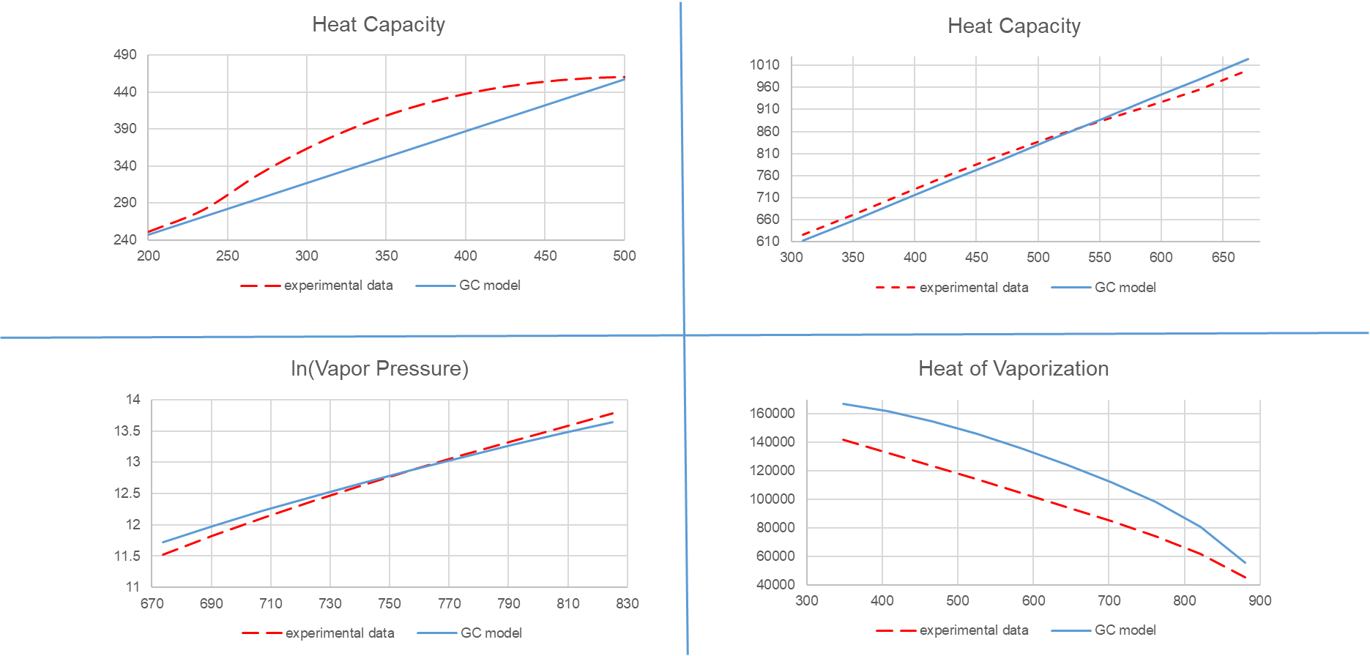
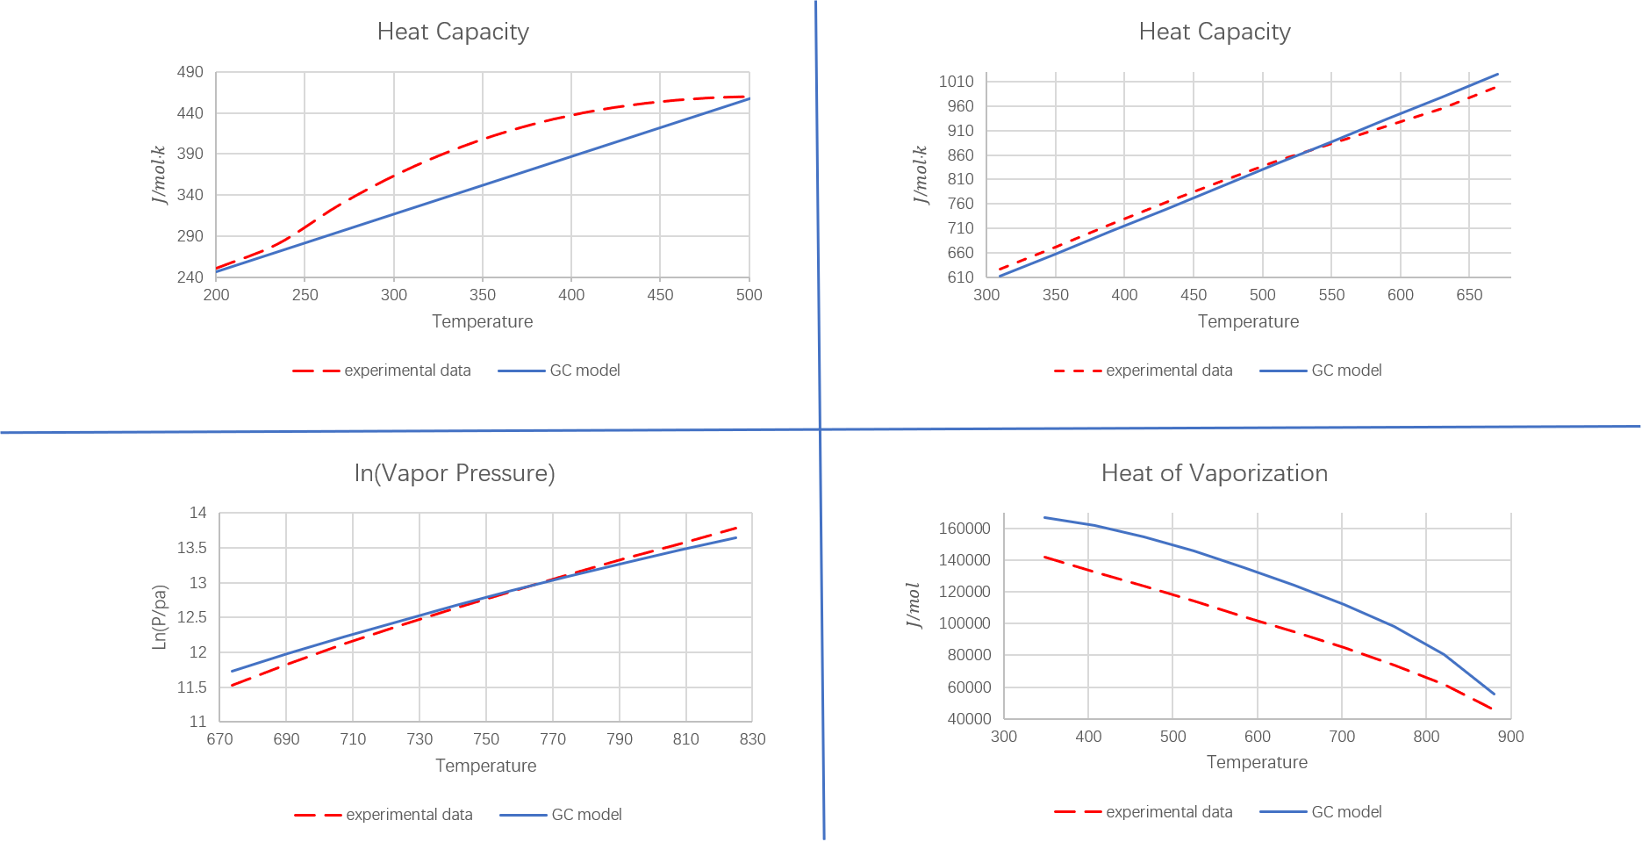
Fig.2 GC model performance
Prediction Performance of the GC Model for Features with Explicit Expression

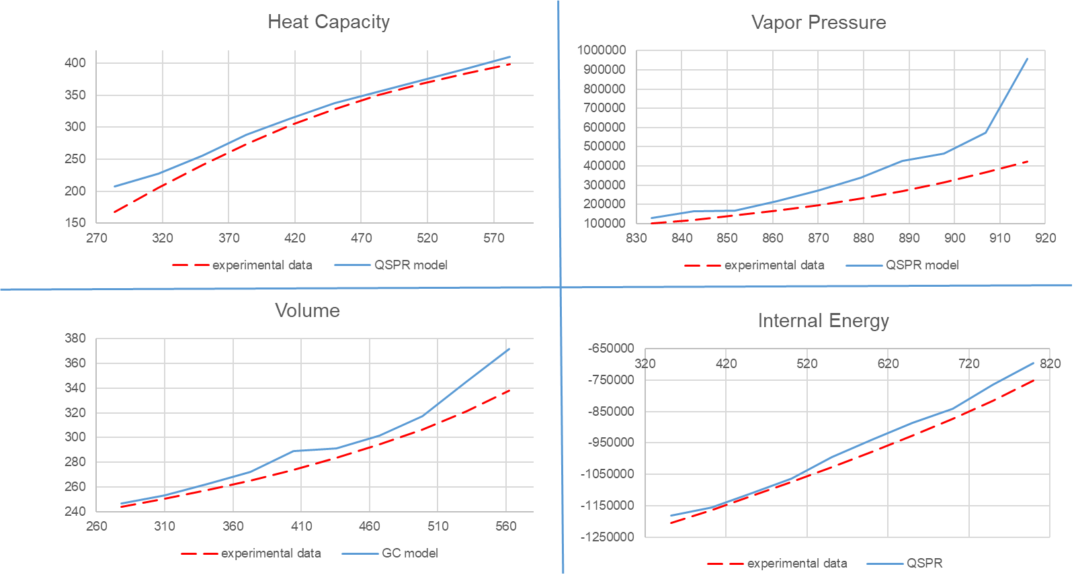
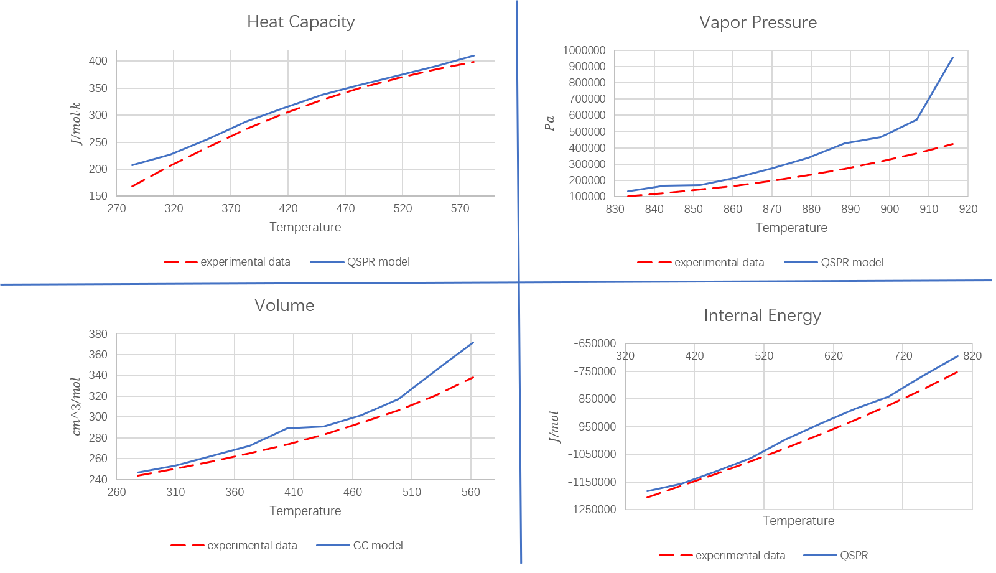
Fig.3 QSPR model performance
QSPR Model Performance for Predicting Implicit Expression Feature Models

3 Proposed hybrid modeling framework

3.1 Conceptual overview
Current approaches to temperature-dependent property prediction face a fundamental limitation: they treat experimental data at different temperatures as independent points, failing to capture the underlying continuous relationship. To address this, we introduce a hybrid modeling framework that shifts the focus from predicting isolated values to learning the complete temperature-dependent behavior.
We present two strategies that implement this new approach. The first strategy builds continuous trends using multiple reference points to guide the prediction of temperature-dependent behavior. The second establishes a baseline model regressed from experimental data to characterize the fundamental trend, and then learns the systematic deviations from this baseline. A flowchart illustrating this overall framework is provided in Fig. 4.
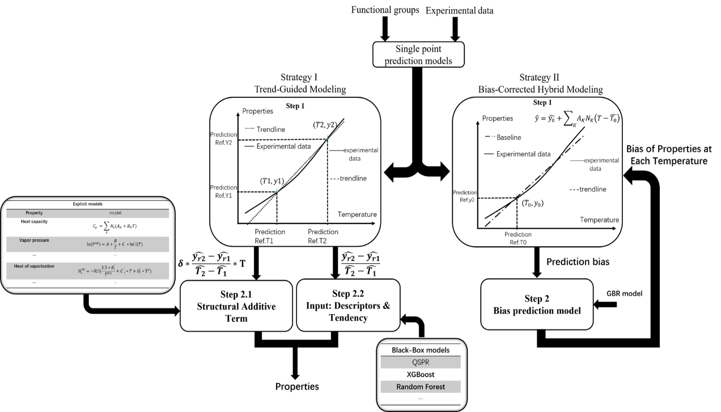
Fig.4 Flowchart of the hybrid modeling framework integrating temperature tendency and physical anchoring approaches

3.2 Strategy I – Trend-Guided modeling
Table.1 Linearity assessment of ten temperature-dependent thermophysical properties.
Property | Mean$R^{2}$ | Lowest $R^{2}$ | Highest $R^{2}$ | Numbers of R²<0.95
$$C_{p}$$ | 0.9768 | 0.6234 | 0.9998 | 27
$$ΔHvap$$ | 0.9843 | 0.5055 | 0.9998 | 8
$$U$$ | 0.9932 | 0.9807 | 0.9990 | 0
$$ρ_{L}$$ | 0.9904 | 0.9854 | 1.0000 | 0
$$H$$ | 0.9948 | 0.9864 | 0.9998 | 0
$$Ex$$ | 0.9909 | 0.9685 | 0.9992 | 0
$$G$$ | 0.9964 | 0.9828 | 0.9997 | 0
$$γ$$ | 0.9927 | 0.9883 | 0.9972 | 0
$$P_{vap}$$ | 0.9942 | 0.9791 | 0.9999 | 0
$$V$$ | 0.9731 | 0.8871 | 1.0000 | 4
By fitting a linear trend line to the experimental data of 10 temperature-dependent properties, as shown in the table above, it can be observed that all the properties exhibit a strong linear relationship, with an average R² value greater than 0.97. (Note that the vapor pressure data was log-transformed before fitting.) Therefore, high-accuracy prediction models at two physically meaningful temperature points (e.g., at the critical temperature (T_{c}) Tc and the normal boiling point (T_{b})Tb) are used to estimate the temperature tendency of the property.

3.2.1 Framework for explicit (mechanistic) models
The modeling of temperature dependence for explicit expression-based models is accomplished through the following two-step framework:
Step 1: Construct four foundational models regressed from molecular structure: two for predicting the reference temperatures $\hat{T_{1}}$​, $\hat{T_{2}}$, and two for estimating the corresponding properties at these points $\hat{y_{r1}}$​,$\hat{y_{r2}}$. The slope of the property trend line between the two reference points is then derived as:
$$\begin{aligned}tendency=\frac{\hat{y_{r2}}-\hat{y_{r1}}}{\hat{T_{2}}-\hat{T_{1}}}\#\left(9\right)\end{aligned}$$
Step 2: Incorporate this slope into a baseline explicit model by introducing a temperature correction term. The augmented model takes the form:
$$\begin{aligned}\hat{y}=f_{0}\left(N_{k},T,MW,……\right)+δ*\frac{\hat{y_{r2}}-\hat{y_{r1}}}{\hat{T_{2}}-\hat{T_{1}}}*T\#\left(10\right)\end{aligned}$$
Here, $f_{0}\left(N_{k},T,MW,……\right)$ denotes the original mechanistic or empirical model. The temperature-inclined correction is weighted by a coefficient $δ$ and scaled by the temperature $T$. This structure enables the model to adaptively capture temperature-driven behavior in a manner consistent with molecular-level insights.

3.2.2 Framework for black-box (machine learning) implicit models
The temperature-dependent modeling for purely data-driven (black-box) implicit models follows a two-step procedure:
Step 1: Construct four predictive models regressed from molecular structure: two for estimating the reference temperatures $\hat{T_{1}}$​, $\hat{T_{2}}$, and two for predicting the corresponding properties at these points $\hat{y_{r1}}$​,$\hat{y_{r2}}$. The temperature tendency of the property between the two reference points is then calculated as:
$$\begin{aligned}tendency=\frac{\hat{y_{r2}}-\hat{y_{r1}}}{\hat{T_{2}}-\hat{T_{1}}}\#\left(11\right)\end{aligned}$$
Step 2: Integrate this temperature tendency as an additional input feature into the original data-driven model. Rather than modifying the model architecture, the slope is treated as a new feature that enables the model to learn temperature-dependent relationships directly. The enhanced model formulation becomes:
$$\begin{aligned}\hat{y}=f_{0}\left(N_{k},T,MW,……,\frac{\hat{y_{r2}}-\hat{y_{r1}}}{\hat{T_{2}}-\hat{T_{1}}}\right)\#\left(12\right)\end{aligned}$$
Here, $f_{0}\left(N_{k},T,MW,……\right)$represents the original black-box model that learns structure-property relationships directly from data.

3.2.3 Physical significance
The physical significance of Strategy I lies in its fundamental departure from discrete-point prediction. By introducing a "temperature tendency" derived directly from experimental data points, the method injects prior physical intuition about continuous, smooth property evolution. This data-driven yet physics-aware approach not only enhances robustness against experimental noise but also ensures more reliable extrapolation and interpolation. Crucially, it bridges the gap between discrete experimental observations and continuous theoretical physical models.

3.3 Strategy II–Bias-Corrected hybrid modeling
The conceptual foundation of Strategy II stems from a critical observation of purely data-driven machine learning methods. While these algorithms excel at identifying complex patterns in data, we propose that instead of feeding all data directly into a black-box model, a more effective approach involves establishing a predictive baseline model first. This baseline is regressed from raw experimental data to capture the fundamental trend, after which machine learning is employed specifically to compensate for the deviations between this baseline and the actual measured values.

3.3.1 Baseline model construction
The hybrid framework begins by establishing a physically-grounded baseline. Two preliminary models are first constructed to predict a reference temperature, $\hat{T_{0}}$​, and the corresponding property value at that temperature, $\hat{y_{0}}$​, directly from the molecular structure. This reference prediction, $\hat{y_{0}}$​, serves as the intercept for a linear baseline model. The slope of this baseline is determined using group contribution methods, resulting in the following expression for the baseline prediction $\hat{y}$:
$$\begin{aligned}\hat{y}=\hat{y_{0}}+\sum_{K}{A_{K}N_{K}\left(T-\hat{T_{0}}\right)}\#\left(13\right)\end{aligned}$$
Here, $\hat{y_{0}}$​ is the reference prediction for the property at temperature $\hat{T_{0}}$​, $A_{K}$ denotes the group contribution coefficients, $N_{K}$​ represents the counts of molecular groups, and $T-\hat{T_{0}}$ is the temperature deviation from the reference point.

3.3.2 Bias learning and compensation
The baseline model, while physically reasonable, cannot capture all complex, non-linear relationships. To address this, the deviation between the baseline prediction and the actual experimental value is calculated as $b=y-$ $\hat{y}$. A machine learning model is then employed to predict this systematic bias:
$$\begin{aligned}\hat{b}=f_{0}\left(N_{k},T,MW…… \right)\#\left(14\right)\end{aligned}$$
This model, $f_{0}$, learns the residual errors of the baseline using a set of features including molecular descriptors, temperature, and molecular weight. The final, refined prediction is obtained by compensating the baseline output with the predicted bias:
$$\begin{aligned}\check{y}=\hat{y}+b\#\left(15\right)\end{aligned}$$
This crucial step allows the hybrid model to leverage the robustness of the physical baseline while incorporating the flexibility of machine learning to capture intricate patterns that the baseline alone cannot represent.

3.3.3 Implementation details
The baseline model was implemented using huber regression to determine the group contribution parameters. This robust regression technique was chosen to maintain the physical interpretability of the GC framework while reducing sensitivity to potential outliers in the experimental data. The resulting baseline provides a physically reasonable starting point for predictions across the temperature range.
For bias compensation, we employed a gradient boosting regressor trained on an extended feature set. The input features included molecular functional groups, temperature values and their derived terms, along with the baseline model predictions. This configuration enables the machine learning component to learn the complex, non-linear relationships between molecular structure, temperature conditions, and the systematic residuals of the baseline model, while the gradient boosting algorithm provides the necessary flexibility to capture these intricate patterns effectively.

3.3.4 Advantages
This hybrid methodology provides clear advantages over purely black-box machine learning approaches. Its primary strength lies in ensuring physical plausibility by anchoring predictions to a group-contribution-based baseline that inherently follows thermodynamic principles, preventing physically implausible results that often occur with purely data-driven models, particularly during extrapolation. Furthermore, it offers enhanced interpretability: the baseline establishes a physically meaningful reference, while the machine learning component specifically quantifies complex deviations from this reference. This enables researchers to distinguish between well-understood physical effects captured by the baseline and more intricate patterns learned from data. Finally, by decomposing the problem this way, the approach achieves greater data efficiency and robustness, as the machine learning model only needs to learn residual patterns rather than the complete physical relationship from scratch.

4. Results and discussion

4.1 Data and evaluation framework
To evaluate the effectiveness of the proposed strategies, we conducted a systematic performance comparison across different modeling frameworks. For properties with established explicit expressions, we enhanced the predictive model through Strategy I by incorporating the temperature tendency (slope) as an additional input feature, denoted by a single plus (+) suffix. For black-box models where no explicit formulation exists, we implemented either Strategy I (+) or Strategy II (denoted by a double plus ++) using random forest as the representative algorithm. We also examined the effect of Strategy I on standard QSPR models. All model variants are clearly distinguished using this notation system in subsequent results and discussions. All property data were obtained from ASPEN Plus, with predictions performed for ten different properties as summarized in the table below.
Table.2 Summary of experimental data points for the ten evaluated temperature-dependent properties, For each substance, data was collected at 10 different temperature points. Experimental data were obtained from Aspen Plus.
 | Properties | Symbol | Data points
1 | Heat capacity | $$J/mol·k$$ | 2070
2 | Vapor pressure | $$Pa$$ | 2090
3 | Heat of vaporization | $$J/mol$$ | 2040
4 | Volume | $${cm}^{3}/mol$$ | 2080
5 | Internal energy | $$J/mol$$ | 2070
6 | Pure component enthalpy | $$J/mol$$ | 2070
7 | pure component exergy | $$J/mol$$ | 2050
8 | pure component isentropic exponent | 1 | 2070
9 | Liquid density | $$g/ml$$ | 2070
10 | Pure component Gibbs free energy | $$J/mol$$ | 2050
Table 2 presents a summary of the experimental data points for the ten evaluated temperature-dependent properties. For each substance, data were collected at 10 different temperature points, ensuring a comprehensive representation of the property’s behavior across a range of temperatures. The experimental data, which form the basis of the evaluations, were obtained from Aspen Plus, a widely used process simulation tool that provides reliable thermophysical property data for a variety of substances.
This table provides the raw data points used in the subsequent analyses, which are critical for comparing the predictive accuracy of different models. The selection of temperature points for each substance was made to capture the essential temperature-dependent trends of the properties, ensuring that the data reflect realistic conditions commonly encountered in industrial processes.

4.2 Comparative performance analysis
Model performance was quantitatively assessed using multiple metrics: the coefficient of determination (R²) R² for overall goodness-of-fit, mean squared error (MSE) MSE for absolute error magnitude, and the percentage of predictions falling within strict error thresholds of ≤1%, ≤5%, and ≤10%, providing comprehensive insight into prediction accuracy and reliability across different tolerance levels.
The overall performance of the models for predicting the ten target properties is summarized in the table below. Results from the GC-based model are presented exclusively for heat capacity, vapor pressure, and heat of vaporization. For the remaining properties, no established GC-based models were available, and the corresponding entries are left blank.
Table.3 Overall predictive performance of baseline and enhanced models for ten thermophysical properties Overall predictive performance of baseline and enhanced models for ten thermophysical properties. GC, ML, and QSPR represent the baseline models, "+" indicates the use of Strategy 1, and "++" indicates the use of Strategy 2.
Properties |  | GC | GC+ | ML | ML+ | ML++ | QSPR | QSPR+
$$C_{p}$$ | $$R^{2}$$ | 0.9918 | 0.9924 | 0.9986 | 0.9988 | 0.9981 | 0.9994 | 0.9994
$$C_{p}$$ | $$MSE$$ | 16.08 | 14.89 | 2.78 | 2.43 | 3.66 | 1.19 | 1.14
$$P_{vap}$$ | $$R^{2}$$ | 0.9033 | 0.9194 | 0.9647 | 0.9715 | 0.9914 | 0.9886 | 0.9901
$$P_{vap}$$ | $$MSE$$ | 63.04 | 52.58 | 23.04 | 18.55 | 5.59 | 7.41 | 6.43
$$ΔHvap$$ | $$R^{2}$$ | 0.9260 | 0.9534 | 0.9893 | 0.9950 | 0.9941 | 0.9929 | 0.9961
$$ΔHvap$$ | $$MSE$$ | 64.55 | 40.66 | 9.37 | 4.34 | 5.14 | 6.15 | 3.40
$$V$$ | $$R^{2}$$ |  |  | 0.9981 | 0.9988 | 0.9985 | 0.9991 | 0.9992
$$V$$ | $$MSE$$ |  |  | 89.56 | 57.64 | 73.67 | 41.83 | 37.78
$$U$$ | $$R^{2}$$ |  |  | 0.9987 | 0.9989 | 0.9996 | 0.9991 | 0.9992
$$U$$ | $$MSE$$ |  |  | 18.54 | 15.68 | 6.36 | 12.59 | 11.51
$$H$$ | $$R^{2}$$ |  |  | 0.9991 | 0.9991 | 0.9996 | 0.9991 | 0.9992
$$H$$ | $$MSE$$ |  |  | 13.62 | 13.08 | 6.18 | 13.17 | 11.00
$$Ex$$ | $$R^{2}$$ |  |  | 0.9962 | 0.9991 | 0.9987 | 0.9992 | 0.9992
$$Ex$$ | $$MSE$$ |  |  | 16.76 | 3.99 | 5.90 | 3.59 | 3.53
$$γ$$ | $$R^{2}$$ |  |  | 0.9894 | 0.9955 | 0.9956 | 0.9931 | 0.9955
$$γ$$ | $$MSE$$ |  |  | 93.74 | 39.74 | 39.37 | 61.24 | 40.08
$$ρ_{L}$$ | $$R^{2}$$ |  |  | 0.9902 | 0.9948 | 0.9957 | 0.9932 | 0.9950
$$ρ_{L}$$ | $$MSE$$ |  |  | 18.23 | 9.61 | 8.00 | 12.53 | 9.23
$$G$$ | $$R^{2}$$ |  |  | 0.9933 | 0.9958 | 0.9975 | 0.9957 | 0.9971
$$G$$ | $$MSE$$ |  |  | 21.32 | 13.40 | 8.05 | 13.80 | 9.27

The results clearly indicate that both Strategy I and II serve as powerful enhancers, delivering significant performance gains across diverse model architectures. Specifically, Strategy I consistently improved predictions, reducing MSE by 19% for QSPR, ~20% for explicit, and 36% for black-box models. Strategy II, in particular, proved to be exceptionally effective for complex machine learning models, achieving a remarkable 47% MSE reduction.

4.3 Cumulative error distribution
A more detailed analysis of prediction errors further validates the advantage of the proposed model. Figure 4 illustrates the proportion of test data points for which the absolute prediction error falls within three critical thresholds: $≤$1%, $≤$5%, and $≤$10%.
Table.4 Cumulative accuracy distribution across deviation thresholds (1%, 5%, and 10%). The number of temperature feature prediction points within these deviation ranges.
Properties |  | GC | GC+ | ML | ML+ | ML++ | QSPR | QSPR+
$$C_{p}$$ | $≤$1% | 380 | 406 | 987 | 993 | 778 | 1244 | 1256
$$C_{p}$$ | $≤$5% | 1519 | 1494 | 2004 | 2006 | 1858 | 2032 | 2034
$$C_{p}$$ | $≤$10% | 1884 | 1909 | 2060 | 2056 | 2017 | 2066 | 2067
$$P_{vap}$$ | $≤$1% | 198 | 219 | 249 | 253 | 335 | 308 | 311
$$P_{vap}$$ | $≤$5% | 865 | 930 | 960 | 1030 | 1377 | 1235 | 1252
$$P_{vap}$$ | $≤$10% | 1332 | 1389 | 1571 | 1557 | 1810 | 1736 | 1756
$$ΔHvap$$ | $≤$1% | 224 | 223 | 600 | 727 | 647 | 823 | 939
$$ΔHvap$$ | $≤$5% | 935 | 984 | 1670 | 1819 | 1806 | 1795 | 1919
$$ΔHvap$$ | $≤$10% | 1493 | 1572 | 1969 | 2010 | 1992 | 1990 | 2019
$$V$$ | $≤$1% |  |  | 1148 | 1192 | 1080 | 1410 | 1629
$$V$$ | $≤$5% |  |  | 2036 | 2048 | 2025 | 2064 | 2072
$$V$$ | $≤$10% |  |  | 2067 | 2075 | 2066 | 2078 | 2079
$$U$$ | $≤$1% |  |  | 1240 | 1276 | 1312 | 1381 | 1409
$$U$$ | $≤$5% |  |  | 1914 | 1922 | 1941 | 1944 | 1959
$$U$$ | $≤$10% |  |  | 1982 | 2001 | 1997 | 2008 | 2008
$$H$$ | $≤$1% |  |  | 1321 | 1333 | 1401 | 1431 | 1452
$$H$$ | $≤$5% |  |  | 1959 | 1956 | 1959 | 1984 | 1981
$$H$$ | $≤$10% |  |  | 2006 | 2004 | 1996 | 2025 | 2021
$$Ex$$ | $≤$1% |  |  | 420 | 492 | 367 | 524 | 553
$$Ex$$ | $≤$5% |  |  | 1233 | 1397 | 1229 | 1343 | 1474
$$Ex$$ | $≤$10% |  |  | 1516 | 1685 | 1548 | 1619 | 1718
γγ | $≤$1% |  |  | 1326 | 1417 | 1436 | 1380 | 1456
γγ | $≤$5% |  |  | 2023 | 2060 | 2062 | 2048 | 2054
γγ | $≤$10% |  |  | 2070 | 2070 | 2070 | 2070 | 2070
$$ρ_{L}$$ | $≤$1% |  |  | 1348 | 1537 | 1515 | 1434 | 1518
$$ρ_{L}$$ | $≤$5% |  |  | 2022 | 2068 | 2062 | 2053 | 2064
$$ρ_{L}$$ | $≤$10% |  |  | 2070 | 2070 | 2070 | 2070 | 2070
$$G$$ | $≤$1% |  |  | 810 | 843 | 468 | 1001 | 1021
$$G$$ | $≤$5% |  |  | 1454 | 1506 | 1264 | 1623 | 1645
$$G$$ | $≤$10% |  |  | 1663 | 1744 | 1529 | 1802 | 1811

Table.4 presents the total number of predictions with absolute deviations within ≤1%, ≤5%, and ≤10% across all models. It is clearly observed that nearly all models incorporating the two proposed strategies show significant improvement in prediction counts across all error thresholds compared to their original counterparts. Particularly in the ≤10% deviation range, the reduction in MSE is distinctly reflected, typically accompanied by an increase of approximately 100 data points falling within this accuracy threshold.
Table.5 MSE Improvement Results under Substance Referencing Strategies 1 and 2: Percentage improvement in MSE relative to the original model for each property. Positive values indicate reduced MSE, whereas negative values indicate increased MSE. Blank entries denote cases where the corresponding strategy/model combination was not applicable.
Properties | GC+ | ML+ | ML++ | QSPR+
Cp | 7.40% | 12.59% | -31.65% | 4.20%
Pvap | 16.59% | 19.49% | 75.74% | 13.23%
ΔHvap | 37.01% | 53.68% | 45.14% | 44.72%
V |  | 35.64% | 17.74% | 9.68%
U |  | 15.43% | 65.70% | 8.58%
H |  | 3.96% | 54.63% | 16.48%
Ex |  | 76.19% | 64.80% | 1.67%
γ |  | 57.61% | 58.00% | 34.55%
ρL |  | 47.28% | 56.12% | 26.34%
G |  | 37.15% | 62.24% | 32.83%
Mean | 20.33% | 35.90% | 46.84% | 19.23%
Across the ten thermophysical properties, applying the proposed referencing strategies leads to substantial and broadly consistent reductions in prediction error for the majority of model–property combinations. Using Strategy I, the average MSE decreases by 19.23% for QSPR-based models, 20.33% for explicit regression models, and 35.90% for implicit black-box ML models. For the implicit ML models, Strategy II yields an even larger overall benefit, with the mean MSE reduction reaching 46.84%.
However, a few exceptions can be noted for specific properties, namely heat capacity, heat of vaporization, and pure component enthalpy, where the original models occasionally yield a marginally higher count of accurate predictions. This nuanced behavior can be attributed to the inherent linearity of the underlying property data, as detailed in Table 1. For heat capacity and heat of vaporization, which exhibit relatively lower linearity indices of 0.9768 and 0.9843 respectively, the raw data follows a slightly curved trend. While the introduced linear tendency provides general guidance, it may inadvertently misguide predictions for a small number of data points that were well-predicted by the original, potentially more flexible, model. In the case of enthalpy, which possesses a high linearity of 0.9948, the original model surpasses the enhanced model by merely one data point in the most stringent ≤1% deviation band. This indicates that for properties with such strong inherent linearity, the accuracy of the linear tendency itself becomes critically influential; any minor inaccuracy in estimating this dominant trend can directly impact performance, even overshadowing the model's inherent flexibility in handling minimal non-linearity. Despite these isolated cases, the overarching trend confirms that the integration of physical temperature tendencies offers a substantial net benefit across the vast majority of properties, effectively enhancing both the accuracy and robustness of the predictive models.

4.4 Model interpretation and physical insights
Fig.5 presents the prediction results from different models across three temperature-dependent properties, comparing the original models with their enhanced versions using two different methods. The results clearly illustrate the impact of incorporating trend and reference point information into the prediction process.
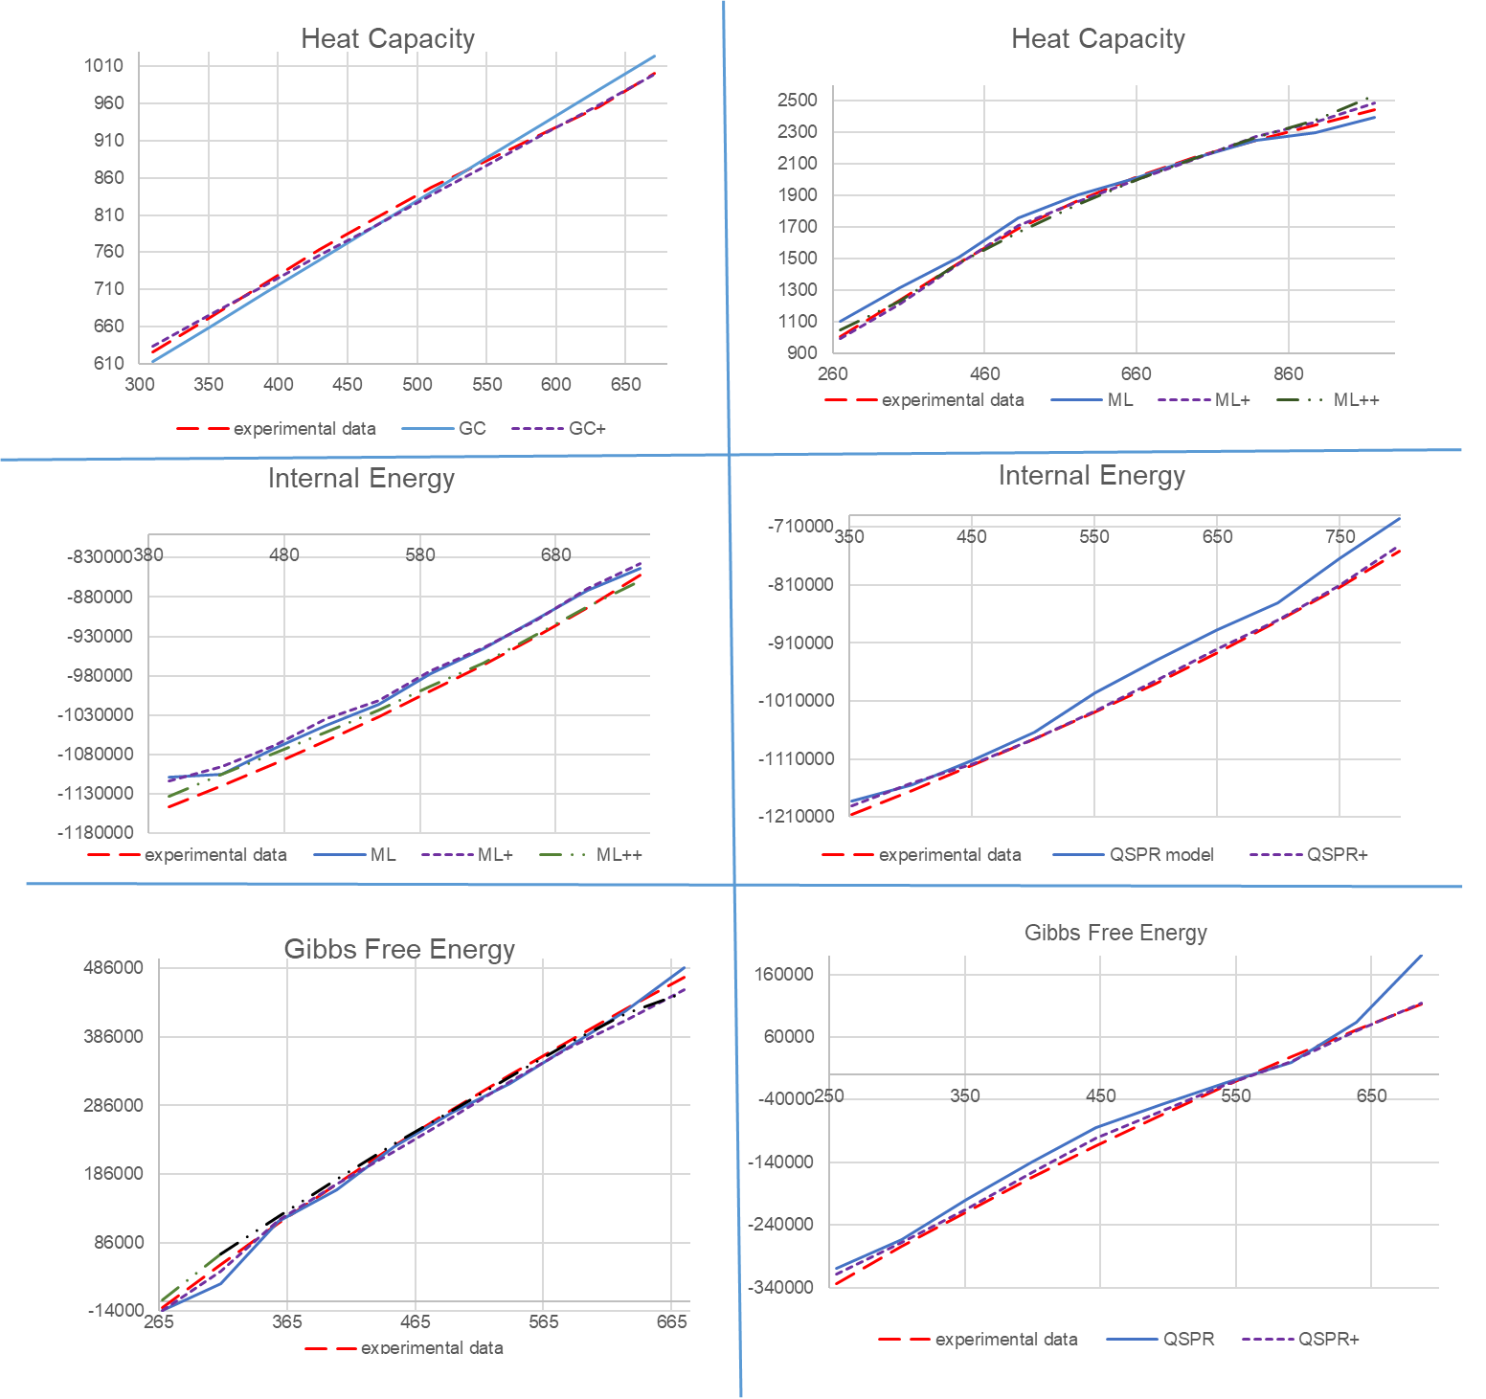
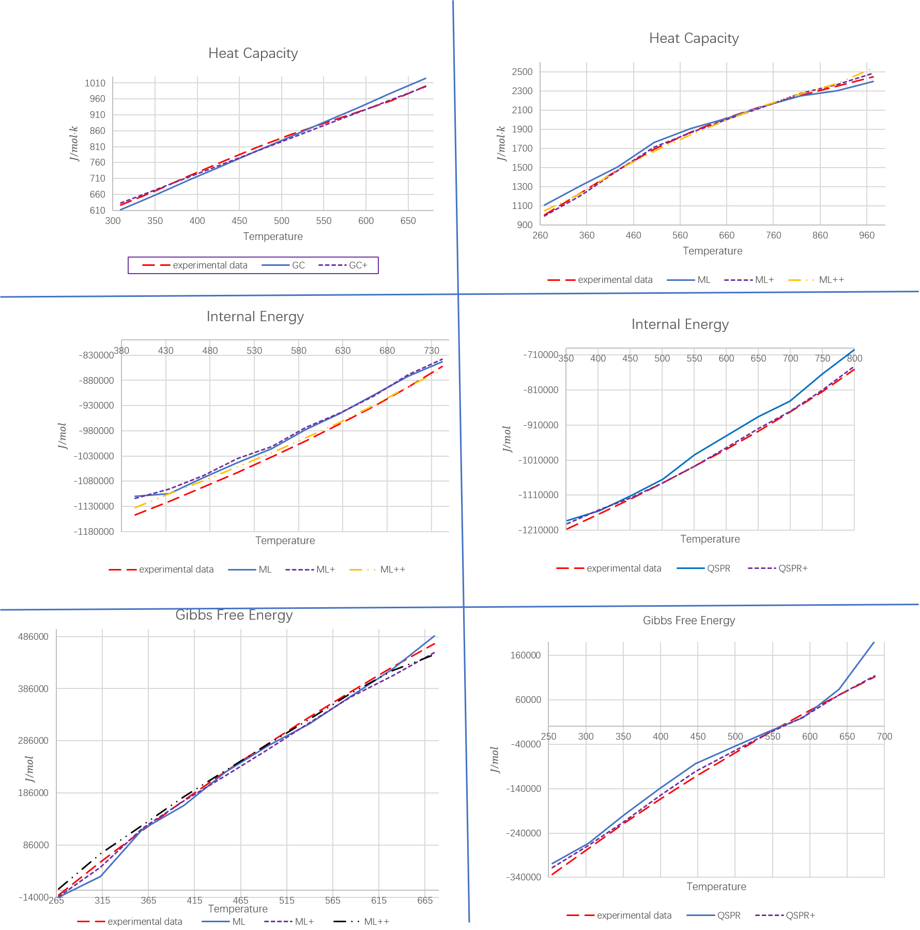
Fig.5 Prediction results from different models
Fig. 5. Prediction Results from Different Models: The figure consists of six subplots, representing three different properties. Each property is compared using two methods and their enhanced versions. In each subplot, the solid line represents the original model's prediction curve, which is used as a reference to distinguish the prediction performance of the enhanced models.
The comparative results highlight a consistent and significant advantage of incorporating physical knowledge into data-driven models. While purely statistical approaches learn patterns directly from the data, they lack awareness of the underlying thermodynamic structure governing temperature-dependent properties. The proposed strategies address this gap by embedding mechanistic priors into the learning process, enabling the hybrid framework to recover physically meaningful trends that conventional models often fail to capture. As illustrated by the predictions, many original models struggle to reproduce the experimental temperature variation because they are trained across multiple compounds using a global loss function that produces parameter sets representing statistical compromises. This leads to persistent prediction gaps for specific compounds—systematic biases that cannot be eliminated without incorporating physical mechanisms.
The physics-informed strategies introduced in this work effectively resolve these issues by embedding fundamental temperature-dependent behavior into the predictive process. In particular, Strategy I incorporates a physically interpretable slope term extracted from high-accuracy reference points such as Tb and Tc. This slope simultaneously acts as a physics-informed feature—encoding the direction and magnitude of temperature effects—and as a molecularly grounded descriptor, since it reflects influences such as intermolecular forces, molecular weight, functional group contributions, and polarizability. By doing so, Strategy I transforms the learning task from predicting an unconstrained surface in (structure, T) → property space to predicting deviations around a physically anchored linearized manifold, analogous to embedding a first-order thermodynamic Taylor expansion as a prior.
Similarly, Strategy II leverages a baseline GC model that encodes known physical relationships between molecular groups and temperature tendencies. Although the baseline is approximate, it captures the dominant trend with clear physical interpretability, while the machine-learning component predicts only the deviation from this baseline. This decomposition substantially reduces the learning difficulty: the ML model focuses solely on complex residual patterns rather than the entire thermodynamic mapping. The baseline also prevents thermodynamic inconsistencies, such as incorrect concavity or unphysical changes in slope. As a result, the overall error decreases because ML is used to refine the nonlinear residual structure rather than reconstruct the entire temperature dependence from scratch. This approach closely mirrors the “Δ-learning” philosophy used in quantum chemistry machine learning, and our framework adopts the same logic for temperature-dependent thermophysical properties.
Properties such as heat capacity, vapor pressure, and enthalpy exhibit slightly weaker improvements under Strategy I, which is consistent with their partially nonlinear temperature behavior, their strong dependence on underlying molecular energetics, and the pronounced curvature that often appears near phase transitions. In contrast, properties that display strong quasi-linear behavior over the studied temperature range—such as internal energy, exergy, and liquid volume—benefit the most from Strategy I because the imposed linear tendency aligns naturally with their physical temperature dependence. Strategy II, however, remains robust across all properties because it does not rely on any linearity assumption; instead, it systematically corrects deviations from a physically grounded baseline while preserving the dominant thermodynamic trend. A major advantage shared by both strategies is their improved extrapolation capability: the slope-based tendency in Strategy I discourages unphysical trend reversals near temperature limits, the GC-derived baseline in Strategy II prevents abrupt discontinuities, and the ML-predicted residuals remain bounded by the physical trend established by the baseline. As a result, the hybrid models behave more consistently and reliably when extended beyond the experimental temperature range, a critical requirement for practical process simulation, design, and optimization.

5 Conclusions
This work presents a unified hybrid modeling framework designed to overcome the fundamental limitations of conventional QSPR and machine learning models in predicting temperature-dependent thermophysical properties. The key idea is to embed physically meaningful temperature trends and correct systematic biases within data-driven workflows, allowing models to learn the full temperature dependence rather than just isolated points. Two complementary strategies were developed and evaluated. Strategy I (Trend-Guided Modeling) uses a slope-based “temperature tendency” derived from two physically meaningful reference predictions. This tendency can be incorporated as a correction term for explicit models or as an additional feature for black-box models. By providing the model with a physics-based representation of monotonic temperature behavior, Strategy I substantially improves interpolation accuracy and mitigates unphysical oscillations. Strategy II (Bias-Corrected Hybrid Modeling) first constructs a group-contribution baseline to capture dominant physical trends. Machine learning is then applied to model the systematic deviations from this baseline. This decomposition allows the ML model to focus solely on the nonlinear, property-specific residual behavior, yielding significant improvements in both predictive accuracy and physical consistency.
Extensive evaluation across ten diverse temperature-dependent properties demonstrates that both strategies consistently enhance predictive performance. Strategy I reduces mean squared error (MSE)MSE by approximately 20–36% depending on the model type, while Strategy II achieves a remarkable 47% reduction for machine learning models. Cumulative accuracy distributions further confirm the robustness of the hybrid framework, with large increases in predictions falling within 1–10% relative error. Beyond improving accuracy, the hybrid approach ensures thermodynamically consistent behavior, enhances interpretability, and provides superior reliability for extrapolation, which is essential for process simulation, optimization, and computer-aided molecular design. Future extensions of this work include incorporating nonlinear temperature tendencies, designing physics-informed loss functions, and integrating uncertainty quantification to better support risk-aware decision-making in chemical engineering applications.
This work presents a unified hybrid modeling framework designed to overcome the fundamental limitations of conventional QSPR and machine learning models in predicting temperature-dependent thermophysical properties. Extensive evaluation across ten diverse temperature-dependent properties demonstrates that both strategies consistently enhance predictive performance. Strategy I reduces MSE by approximately 20–36% depending on the model type, while Strategy II achieves a remarkable 47% reduction for machine learning models. Cumulative accuracy distributions further confirm the robustness of the hybrid framework, with large increases in predictions falling within 1–10% relative error. The key idea of the framework is to embed physically meaningful temperature trends and correct systematic biases within data-driven workflows, allowing models to learn the full temperature dependence rather than just isolated points.

Two distinct strategies were developed and evaluated. Strategy I uses a slope-based temperature tendency derived from two physically meaningful reference predictions. This tendency can be incorporated as a correction term for explicit models or as an additional feature for implicit models. By providing the model with a physics-based representation of monotonic temperature behavior, Strategy I substantially improves interpolation accuracy and mitigates unphysical oscillations.
Strategy II first constructs a group-contribution baseline to capture dominant physical trends. Machine learning is then applied to model the systematic deviations from this baseline. This decomposition allows the ML model to focus solely on the nonlinear, property-specific residual behavior, yielding significant improvements in both predictive accuracy and physical consistency. Additionally, Strategy II provides a foundational predictive approach for properties that currently lack temperature-dependent prediction models. By using a special temperature point prediction model as an anchor, it regresses a baseline model and compensates for prediction residuals, enabling the model to handle properties without explicit temperature variation features.

Beyond improving accuracy, the hybrid approach ensures thermodynamically consistent behavior, enhances interpretability, and provides superior reliability for extrapolation, which is essential for process simulation, optimization, and computer-aided molecular design. Future extensions of this work include incorporating nonlinear temperature tendencies, designing physics-informed loss functions, and integrating uncertainty quantification to better support risk-aware decision-making in chemical engineering applications.
Appendix A: Full List of Keywords Used for Data Retrieval
Temperature-dependent topic: ("organic compound*" OR "organic chemical*") AND (QSPR OR "quantitative structure-property relationship" OR "model" OR "estimation") AND ("temperature dependen*" OR "thermal propert*" OR "vapor pressure" OR "heat capacity")
Single-point topic: ("at 298 K" OR "at 300 K" OR "at 25 C" OR "room temperature" OR "ambient temperature" OR isothermal OR STP OR "standard conditions") AND ("vapor pressure" OR viscosity OR "heat capacity" OR density OR "thermal conductivity" OR "surface tension" OR propert*) AND (predict* OR model* OR correlation* OR "group contribution" OR QSPR OR QSAR OR "machine learning" OR "parameter estimation" OR regression)

REFERENCE
[1] Rumble, J. R. (Ed.). (2022). *CRC Handbook of Chemistry and Physics* (103rd ed.). CRC Press.
[2] Smith, M. B. (2020). *March's Advanced Organic Chemistry: Reactions, Mechanisms, and Structure* (8th ed.). John Wiley & Sons.
[3] Armarego, W. L. F. (2017). *Purification of Laboratory Chemicals* (8th ed.). Butterworth-Heinemann.
[4] Patrick, G. L. (2023). *An Introduction to Medicinal Chemistry* (7th ed.). Oxford University Press.
[5] Young, R. J., & Lovell, P. A. (2011). *Introduction to Polymers* (3rd ed.). CRC Press.
[6] Friend, R. H., et al. (1999). Electroluminescence in conjugated polymers. *Nature*, 397(6715), 121-128.
[7] Marrero J, Gani R. Group-contribution based estimation of pure component properties. Fluid Phase Equilib. 2001;183–184:183–208.
[8] Díaz-Tovar C-A, Gani R, Sarup B. Lipid technology: property prediction and process design/analysis in the edible oil and biodiesel industries. Fluid Phase Equilibr. 2011;302(1–2):284–293.
[9] Klincewicz K, Reid RC. Estimation of critical properties with group contribution methods. AIChE J. 1984;30(1):137–142.
[10] Joback, K. G., & Reid, R. C. (1987). Estimation of pure-component properties from group-contributions. Chemical Engineering Communications, 57(1-6), 233-243.
[11] Eriani, R., Gani, R., & Meirelles, A. J. A. (2009). Prediction of heat capacities and heats of vaporization of organic liquids by group contribution methods. Fluid Phase Equilibria, 283(1-2), 49-55.
[12] Nannoolal, Y., Rarey, J., & Ramjugernath, D. (2004). Estimation of the vapour pressure of non-electrolyte organic compounds via group contributions and group interactions. Fluid Phase Equilibria, 226, 45-63.
[13] Ceriani, R., Gonçalves, C. B., Rabelo, J., Caruso, M., Cunha, A. C. C., Cavaleri, F. W., Batista, E. A. C., & Meirelles, A. J. A. Group Contribution Model for Predicting Viscosity of Fatty Compounds. Journal of Chemical & Engineering Data, 2007, 52(3), 965–972.
[14] Todeschini, R., & Gramatica, P. (1997). The WHIM theory: new 3D molecular descriptors for QSAR in environmental modelling. SAR and QSAR in Environmental Research, 7(1-4), 89-115.
[15] Sosnowska, A., Barycki, M., Jagiello, K., Haranczyk, M., Gajewicz, A., Kawai, T., Suzuki, N., & Puzyn, T. (2014). Predicting enthalpy of vaporization for Persistent Organic Pollutants with Quantitative Structure—Property Relationship (QSPR) incorporating the influence of temperature on volatility. Atmospheric Environment, *87*, 10–18.

[16] Huang, X. Y., Chen, J. W., Gao, L. N., Ding, G. H., Zhao, Y. Z., & Schramm, K. W. (2004). Data evaluations and quantitative predictive models for vapor pressures of polycyclic aromatic hydrocarbons at different temperatures. SAR and QSAR in Environmental Research, 15(2), 115-125.
[17] Cheng, Z., Yang, B., Chen, Q., Gao, X., Tan, Y., Ma, Y., & Shen, Z. (2018). A Quantitative-Structure-Activity-Relationship (QSAR) model for the reaction rate constants of organic compounds during the ozonation process at different temperatures. Chemical Engineering Journal, *353*, 288–296.
[18] Yin, J., Jia, Q., Yan, F., & Wang, Q. (2017). Predicting heat capacity of gas for diverse organic compounds at different temperatures. Fluid Phase Equilibria, *446*, 1–8.
[19] Shan, Y., Wu, Q., Yuan, H., & Liu, W. (2024). Develop machine learning-based model and automated process for predicting liquid heat capacity of organics at different temperatures. Fluid Phase Equilibria, 584, 114132.
[20] Ye, Z., & Ouyang, D. (2021). Prediction of small-molecule compound solubility in organic solvents by machine learning algorithms. Journal of Cheminformatics, *13*(1), 98.
[21] Rittig, J. G.; Ben Hicham, K.; Schweidtmann, A. M.; Dahmen, M.; Mitsos, A. Graph Neural Networks for Temperature-Dependent Activity Coefficient Prediction of Solutes in Ionic Liquids. Comput. Chem. Eng. 2023, *171*, 108153.
[22]：Zobeiry, N.; Humfeld, K. D. A physics-informed machine learning approach for solving heat transfer problems in optimizing additive manufacturing processes. J. Manuf. Process. 2021, 68, 765-779.

∗ Corresponding author. E-mail address: anjantula@zju.edu.cn.

